|  |
| --- |
|  |
| Capstone Project Document |

**DANDELION**

Report #2 – Data Design

|  |  |  |
| --- | --- | --- |
| **Dandelion** | | |
| **Group Members** | Vũ Công Chính | SE02585 |
| Lưu Ngọc Mạnh | SE02619 |
| Nguyễn Minh Huy | SE02723 |
| Dương Đức Anh | SE02700 |
| Vũ Ngọc Trung | SE02967 |
| Cao Thị Phương Mai | SE02908 |
| **Supervisor** | Mr. Nguyễn Văn Sang | |
| **Project code** | DDL | |

**- Hanoi, 09/2015 –**

# SIGNATURE PAGE

AUTHOR: Vũ Ngọc Trung 26/09/2015

Team member

REVIEWERS: Lưu Ngọc Mạnh 27/09/2015

Project manager

APPROVAL: Nguyễn Văn Sang --/--/--15

Supervisor

Record of change

*A - Added M - Modified D – Deleted

|  |  |  |  |  |  |
| --- | --- | --- | --- | --- | --- |
| Effective Date | Changed Item | A,M,D | Change Description | Reason for Change | Rev. Number |
| 26/Sep/2015 | Create Data Design | A | Create Data Design | First version | 1.0 |
|  |  |  |  |  |  |
|  |  |  |  |  |  |
|  |  |  |  |  |  |
|  |  |  |  |  |  |
|  |  |  |  |  |  |
|  |  |  |  |  |  |
|  |  |  |  |  |  |
|  |  |  |  |  |  |
|  |  |  |  |  |  |
|  |  |  |  |  |  |
|  |  |  |  |  |  |
|  |  |  |  |  |  |
|  |  |  |  |  |  |
|  |  |  |  |  |  |
|  |  |  |  |  |  |
|  |  |  |  |  |  |
|  |  |  |  |  |  |
|  |  |  |  |  |  |
|  |  |  |  |  |  |
|  |  |  |  |  |  |
|  |  |  |  |  |  |
|  |  |  |  |  |  |
|  |  |  |  |  |  |

Table Contents

SIGNATURE PAGE 1

1 INTRODUCTION 3

1.1 Purpose 3

1.2 Acronyms and Definitions 3

1.3 References 3

1.4 Overview 3

2 Database 4

2.1 Entity Relationship Diagram 4

2.1.1 Entity Relationship Diagram 5

2.1.2 Relationship 5

2.2 Table Diagram 7

2.2.1 User table 8

2.2.2 UserInfo table 8

2.2.3 Project table 9

2.2.4 Question table 10

2.2.5 Category table 10

2.2.6 UpdateLog table 10

2.2.7 Timeline table 11

2.2.8 ReportProject table 11

2.2.9 Remind table 11

2.2.10 Backing table 12

2.2.11 Comment table 12

2.2.12 ReportUser table 13

2.2.13 Slide table 13

2.2.14 Conversation table 15

2.2.15 Message table 15

2.2.16 RewardPkg table 15

# INTRODUCTION

## Purpose

Fly Away Plus data design document describes structure of database and file structure of system including internal file structure as well as interface file structure.

## Acronyms and Definitions

|  |  |
| --- | --- |
| **Acronym & Abbreviation** | **Definition** |
| DDL | Dandelion |
| FU | FPT University |
| Q&A | Question and Answer |

Table ‑: Acronyms and Definitions

## References

|  |  |
| --- | --- |
| **Document** | **Title** |
| Class Design Document | DDL_Class Design_v1.0_EN |
| Architecture Design | DDL_Architectur Design_v1.0_EN |
| Software Requirement Specification | DDL_Software Requirement Specification_v1.0_EN |

Table ‑: References

## Overview

This document describes relationship between entities and properties of each entity.

# Database

## Entity Relationship Diagram

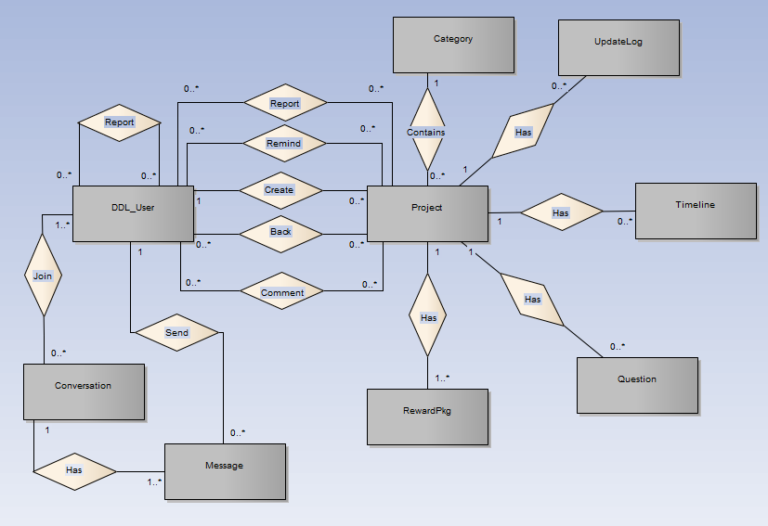

**Figure 2‑1:** Entity Relationship Diagram

### Entity Relationship Diagram

|  |  |  |
| --- | --- | --- |
| **No** | **Entity** | **Description** |
|  | User | User is all people who using DDL feature |
|  | Project | A project which user created, includes content, schedule, photo, video to descripting. |
|  | Category | A category which user use to filter project |
|  | Update | A Update which user use to save/update change of project |
|  | Timeline | A Timeline which descript project’s schedule, when start phase 1, when backer can rewards… |
|  | QuestionAnswer | A QuestionAnswer which save questions and answers of project. |
|  | RewardPkg | A RewardPkg which user distribution rewards by packet |
|  | Conversation | A Conversation which user created and joined to send and receive message together |
|  | Message | A Message which user send or receive to talk together |

**Table 2-3:** Entity description

### Relationship

|  |  |  |  |  |  |
| --- | --- | --- | --- | --- | --- |
| **No** | **Relation** | **Properties** | **From** | **To** | **Description** |
|  | CONTAINS | None | Category | Project | A category contains many projects |
|  | HAS | None | Project | Update | A update of project which was changed by creator |
|  | HAS | None | Project | Timeline | A timeline of project which description about project schedule |
|  | HAS | None | Project | QuestionAnswer | A common question and answer of use project which created by creator |
|  | HAS | None | Project | RewardPkg | A Reward packet of project which creator device to get funded |
|  | COMMENT | UserID  ProjectID | DDL_User | Project | A Comment which user give to project |
|  | BACK | UserID  ProjectID | DDL_User | Project | A project which user backing project |
|  | REMIND | UserID  ProjectID | DDL_User | Project | A Remind which user bookmark a project. |
|  | REPORT | UserID  ProjectID | DDL_User | Project | A Report which user report a project |
|  | CREATE | None | DDL_User | Project | A Create which user created project |
|  | REPORT | ReportUseID  ReportedUseID | DDL_User |  | A Report which User report another user |
|  | JOIN | None | User | Conversation | A Join which user joined or created a conversation |
|  | HAS | None | Conversation | Message | A Has which conversation has message(s) |
|  | SEND | None | DDL_User | Message | A Send which User create and send message |

Table ‑: Relationship description

## Table Diagram

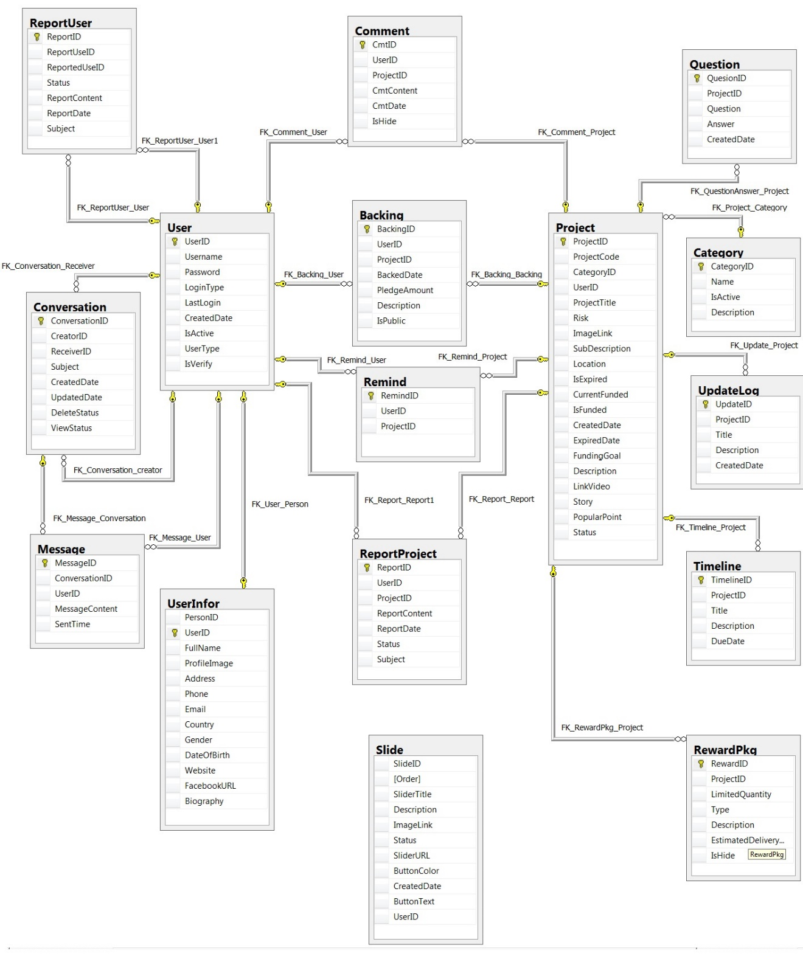

**Figure 2‑2:** Table Diagram

### User table

|  |  |  |  |  |
| --- | --- | --- | --- | --- |
| **No** | **Field Name** | **Type** | **Allow Null** | **Description** |
|  | UserID | int | No | User’s ID |
|  | UserName | String | No | User’s name |
|  | Password | String | No | User’s password |
|  | IsActive | bool |  | User’s active status (inactive, active) |
|  | CreatedDate | Datetime |  | User’s created date |
|  | LoginType | int |  | User’s created type includes: normal, Facebook or both |
|  | LastLogin | Datetime |  | User’s last login |
|  | UserType | Int |  | User’s type (admin or nomal user) |
|  | IsVerify | bool |  | User’ email verify status |

Table ‑: User table

### UserInfo table

|  |  |  |  |  |
| --- | --- | --- | --- | --- |
| **No** | **Field Name** | **Type** | **Allow Null** | **Description** |
|  | UserID | int | No | Person’s ID |
|  | Email | String | No | Person’s email |
|  | FullName | String | No | Person’s full name |
|  | ProfileImage | String |  | Person’s profile image |
|  | Biography | String |  | Person’s biography |
|  | Address | String |  | Person’s address |
|  | Gender | String |  | Person’s gender |
|  | Phone | String |  | Person’s phone number |
|  | DateOfBirth | Datetime |  | Person’s date of birth |
|  | Country | String |  | Person’s country |
|  | Website | String |  | Person’s website |
|  | FacebookURL | String |  | Person’s facebook link |

Table ‑: Person table

### Project table

|  |  |  |  |  |
| --- | --- | --- | --- | --- |
| **No** | **Field Name** | **Type** | **Allow Null** | **Description** |
|  | ProjectID | int | No | Project’s ID |
|  | ProjectCode | String | No | Project’s code with fixed format |
|  | CategoryID | int | No | Project’s category |
|  | UserID | int | No | Project’s UserID who created project |
|  | ProjectTitle | String |  | Project’s title |
|  | Risk | String |  | Project’s risk |
|  | ImageLink | String |  | Project’s image link |
|  | SubDescription | String |  | Project’s sub description |
|  | Location | String |  | Project’s location created |
|  | IsExpired | bool |  | Is Project’s expired |
|  | CurrentFunded | int |  | Project’s funded status |
|  | IsFunded | bool |  | Is Project’s funded |
|  | CreatedDate | datetime |  | Project’s createdDate |
|  | ExpiredDate | datetime |  | Project’s expired date |
|  | FundingGoal | int |  | Project’s funding goal |
|  | Description | String |  | Project’s description |
|  | LinkVideo | String |  | Project’s video link |
|  | Story | String |  | Project’s story |
|  | PopularPoint | int |  | Project’s popular point |
|  | Status | Int |  | Project’s status ( draft, pending, approved, suspended) |

Table ‑: Project table

### Question table

|  |  |  |  |  |
| --- | --- | --- | --- | --- |
| **No** | **Field Name** | **Type** | **Allow Null** | **Description** |
|  | QuestionID | Int | No | question and answer’s ID |
|  | ProjectID | Int | No | question and answer’s project id |
|  | Question | String |  | question and answer’s question |
|  | Answer | String |  | question and answer’s answer |
|  | CreatedDate | Datetime |  | question and answer’s created date |

Table ‑: QuestionAnswer table

### Category table

|  |  |  |  |  |
| --- | --- | --- | --- | --- |
| **No** | **Field Name** | **Type** | **Allow Null** | **Description** |
|  | CategoryID | int | No | Category’s ID |
|  | Name | String |  | Category’s name |
|  | IsActive | bool |  | Category’s active status |
|  | Description | String |  | Category’s description |

Table ‑: Category table

### UpdateLog table

|  |  |  |  |  |
| --- | --- | --- | --- | --- |
| **No** | **Field Name** | **Type** | **Allow Null** | **Description** |
|  | UpdateID | int | No | Update’s ID |
|  | ProjectID | Int | No | Update’s project id |
|  | Title | String |  | Update’s title |
|  | Description | String |  | Update’s description |
|  | CreatedDate | datetime |  | Update’s created date |

Table ‑: Update table

### Timeline table

|  |  |  |  |  |
| --- | --- | --- | --- | --- |
| **No** | **Field Name** | **Type** | **Allow Null** | **Description** |
|  | TimelineID | int | No | Timeline’s ID |
|  | ProjectID | int | No | Timeline’s project id |
|  | Title | String |  | Timeline’s title |
|  | Description | String |  | Timeline’s description |
|  | DueDate | datetime |  | Timeline’s due date |

Table ‑: Timeline table

### ReportProject table

|  |  |  |  |  |
| --- | --- | --- | --- | --- |
| **No** | **Field Name** | **Type** | **Allow Null** | **Description** |
|  | ReportID | int | No | Report ’s ID |
|  | ProjectID | int | No | Report ’s project id |
|  | UserID | int | No | Report ’s user id, who report project |
|  | Subject | String |  | Report ’s subject |
|  | ReportContent | String |  | Report ’s report content |
|  | ReportDate | datetime |  | Report ’s report date |
|  | Status | String |  | Report’s status |

Table ‑: ReportPost table

### Remind table

|  |  |  |  |  |
| --- | --- | --- | --- | --- |
| **No** | **Field Name** | **Type** | **Allow Null** | **Description** |
|  | RemindID | int | No | Remind’s ID |
|  | ProjectID | int | No | Remind’s project id |
|  | UserID | int | No | Remind’s user id |

Table ‑: Remind table

### Backing table

|  |  |  |  |  |
| --- | --- | --- | --- | --- |
| **No** | **Field Name** | **Type** | **Allow Null** | **Description** |
|  | BackingID | int | No | Back’s ID |
|  | UserID | int | No | Back’s user id |
|  | ProjectID | int | No | Back’s project id |
|  | BackedDate | Datetime |  | Back’s date |
|  | PledgeAmount | Int |  | Back’s pledge amount |
|  | Description | String |  | Back’s description |
|  | IsPublic | bool |  | Is Back public |

Table ‑: Backing table

### Comment table

|  |  |  |  |  |
| --- | --- | --- | --- | --- |
| **No** | **Field Name** | **Type** | **Allow Null** | **Description** |
|  | CmtID | int | No | Comment’s ID |
|  | UserID | int | No | Comment’s user id |
|  | ProjectID | int | No | Comment’s project id |
|  | CmtContent | String |  | Comment’s content |
|  | CmtDate | Datetime |  | Comment’s date |
|  | IsHide | bool |  | Is Comment’s hide |

Table ‑: Comment table

### ReportUser table

|  |  |  |  |  |
| --- | --- | --- | --- | --- |
| **No** | **Field Name** | **Type** | **Allow Null** | **Description** |
|  | ReportID | int | No | Report’s ID |
|  | ReportUserID | int | No | Report’s report user ID |
|  | ReportedUserID | int | No | Report’s reported user ID |
|  | Status | String |  | Report’s status |
|  | Subject | String |  | Report ’s subject |
|  | ReportContent | String |  | Report’s content |
|  | ReportDate | datetime |  | Report’s date |

Table ‑: ReportUser table

### Slide table

|  |  |  |  |  |
| --- | --- | --- | --- | --- |
| **No** | **Field Name** | **Type** | **Allow Null** | **Description** |
|  | SlideID | int | No | Slide’s ID |
|  | UserID | Int |  | user id of user who create slide |
|  | SlideTitle | String |  | Slide’s title |
|  | Order | int |  | Slide’s order |
|  | Description | String |  | Slide’s description |
|  | ImageLink | String |  | Slide’s image link |
|  | IsActive | bool |  | Slide’s is Active status |
|  | SliderURL | String |  | Slide’s slide URL |
|  | ButtonColor | String |  | Slide’s button color |
|  | CreatedDate | datetime |  | Slide’s created date |
|  | ButtonText | String |  | Slide’s button text |

Table ‑: Slide table

### Conversation table

|  |  |  |  |  |
| --- | --- | --- | --- | --- |
| **No** | **Field Name** | **Type** | **Allow Null** | **Description** |
|  | ConversationID | int | No | Conversation’s ID |
|  | CreatorID | int | No | Conversation’s creator id |
|  | ReceiverID | int | No | Conversation’s receiver |
|  | Subject | String |  | Conversation’s subject |
|  | CreatedDate | Datetime |  | Conversation’s created date |
|  | UpdatedDate | Datetime |  | Conversation’s update date |
|  | DeleteStatus | int |  | Conversation’s user delete status |
|  | ViewStatus | int |  | Conversation’s user view status |

Table ‑: Conversation table

### Message table

|  |  |  |  |  |
| --- | --- | --- | --- | --- |
| **No** | **Field Name** | **Type** | **Allow Null** | **Description** |
|  | MessageID | int | No | Message’s ID |
|  | ConversationID | int | No | Message’s conversation id |
|  | UserID | int | No | Message’s user id |
|  | MessageContent | String |  | Message’s content |
|  | SentTime | Datetime |  | Message’s sent time |

Table ‑: Message table

### RewardPkg table

|  |  |  |  |  |
| --- | --- | --- | --- | --- |
| **No** | **Field Name** | **Type** | **Allow Null** | **Description** |
|  | RewardID | int | No | Reward’s ID |
|  | ProjectID | int | No | Reward’s project id |
|  | LimitedQuantity | String |  | Reward’s limited quantity |
|  | Type | int |  | Reward’s type |
|  | Description | String |  | Reward’s description |
|  | EstimatedDeliveryDate | datetime |  | Reward’s estimated delivery date |
|  | IsHide | bool |  | Is Reward hide |

Table ‑: reward packet table